Experiment 3 Final Report: Passive Devices

# Part 1: Calibration Measurements

**Gain Measurements:**

|  |  |  |
| --- | --- | --- |
|  | Uncalibrated | Calibrated |
| S11 |  |  |
| S12 |  |  |
| S21 |  |  |
| S22 |  |  |

**Phase Measurements:**

|  |  |
| --- | --- |
| Uncalibrated | Calibrated |
|  |  |

Differences in Magnitude and Phase:

S11 (uncal) > S11 (cal), S22 (uncal) < S22 (cal) which suggests that the calibrated port allows a signal to enter with less noise, it adds more noise to it before the signal exits the port. The reverse is true for the uncalibrated case.

The phase of the uncalibrated case is more violent for the uncalibrated port, and better for the calibrated one. Surprisingly, S12 (cal) is very defined, while the other parameter plots seem to follow in its stride.

# Part 2: Coupler Measurements

S21 gain = -5.79534dB, S12 gain = -5.33342dB, hence transmission between input to coupled port is S21/S12 = -0.46192dB

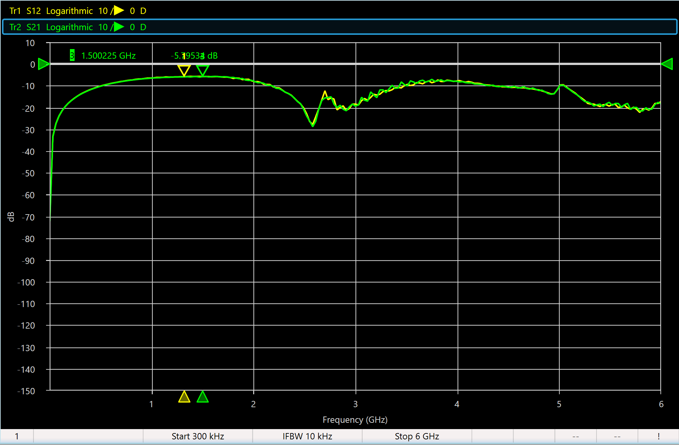

S12 gain = -37.4922 dB, S21 gain = -37.2139 dB, hence transmission between output to coupled port is S21/S12 = 0.2783dB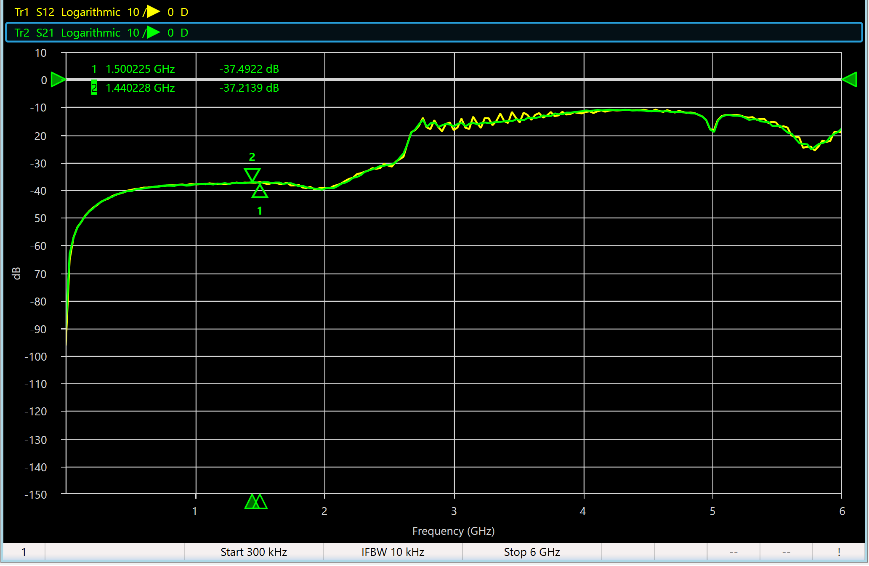

The directivity is 0.2783 - - 0.46192 = 0.74022 dB

Between 800 to 2000 MHz, Insertion loss = gain in dB of (Power_input/Power_output) = (-1.16401 – (-0.77967) = -0.38434 dB. Here, the file that plots input to output port was used.

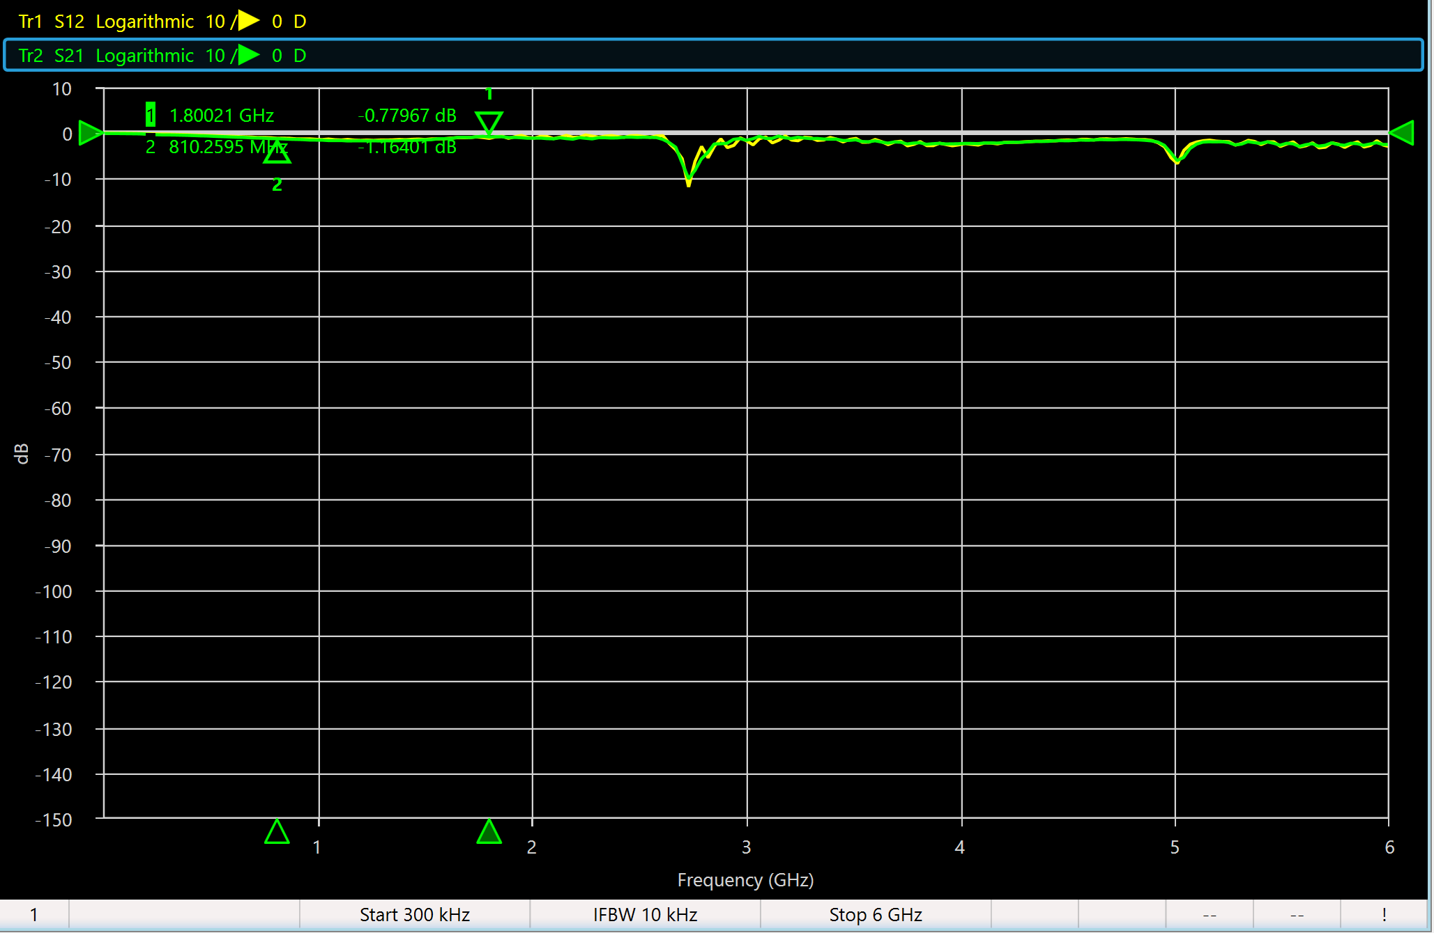

# Part 3: Filter Measurements

VBFZ-2130+:

Bandwidth = 2.55 – 1.71 = 0.84 GHz

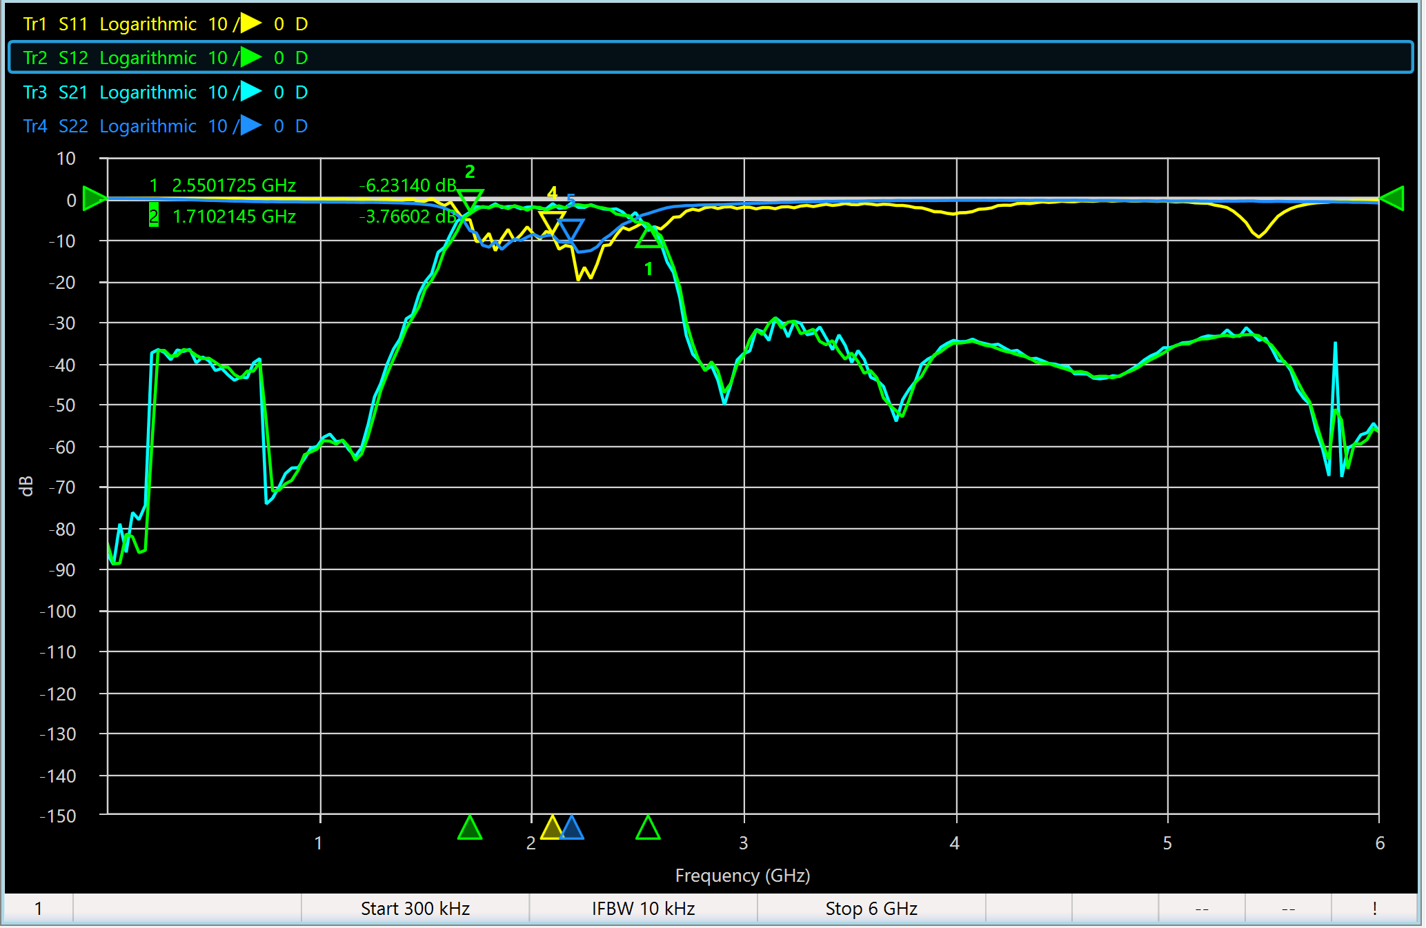

Insertion Loss = S21/S12 = -10.92 +3.77 = -7.15 dB

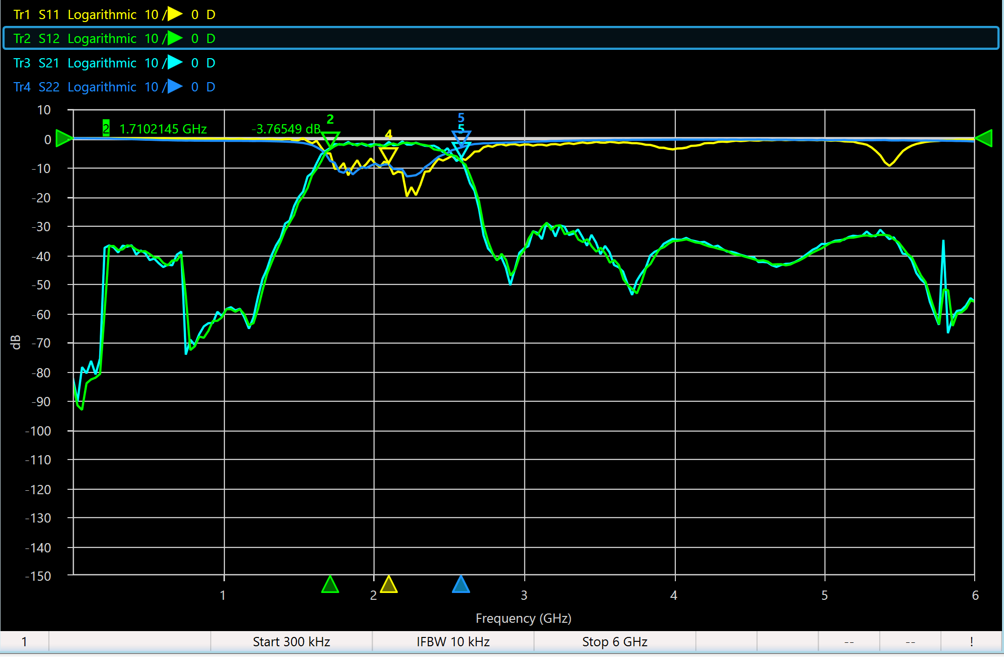

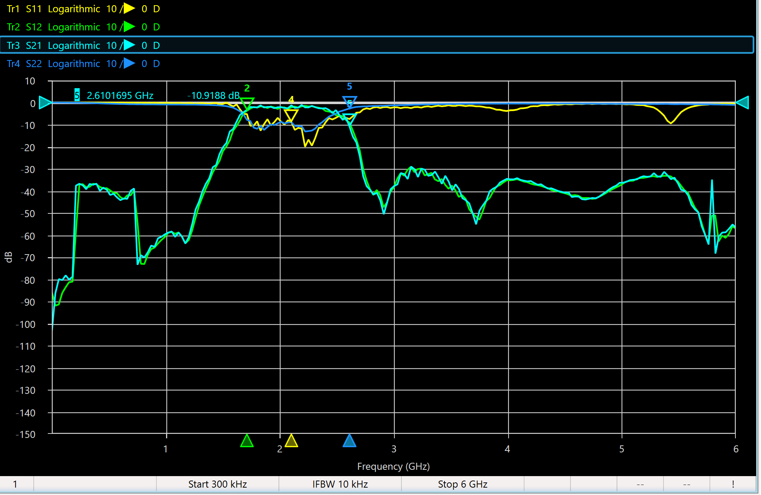

Return Loss = S22/S11 = -2.69 + 8.82 = 6.13 dB

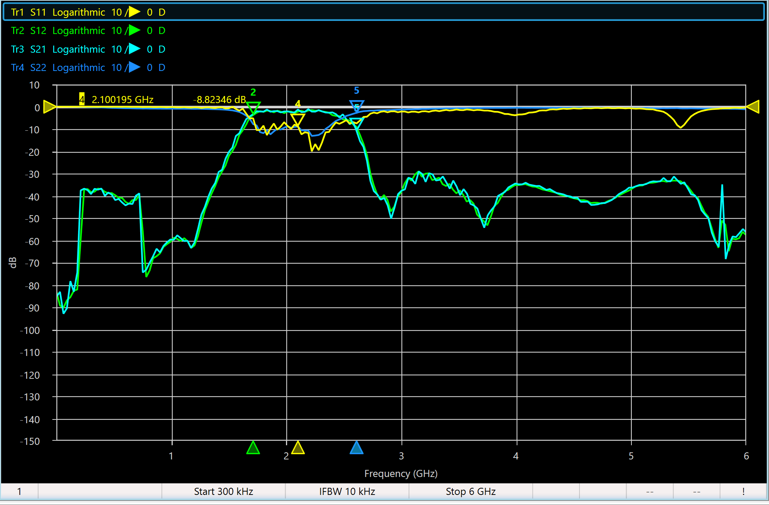

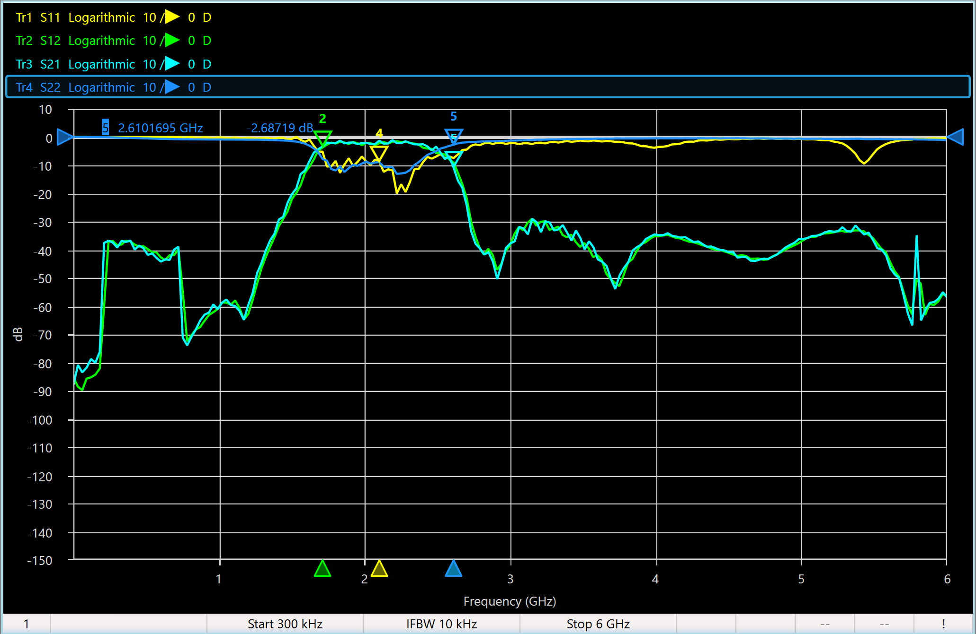

With frequency Response, which is very similar to S12: 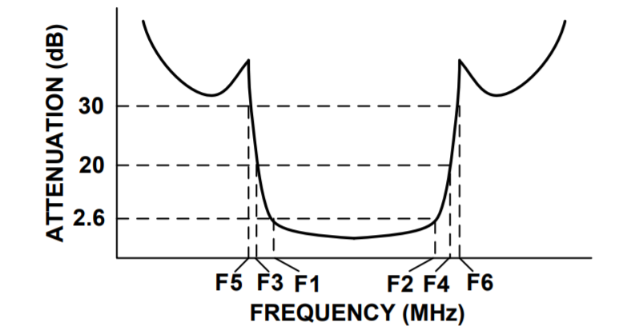

SLP-2400+:

Bandwidth = 2.5 GHz

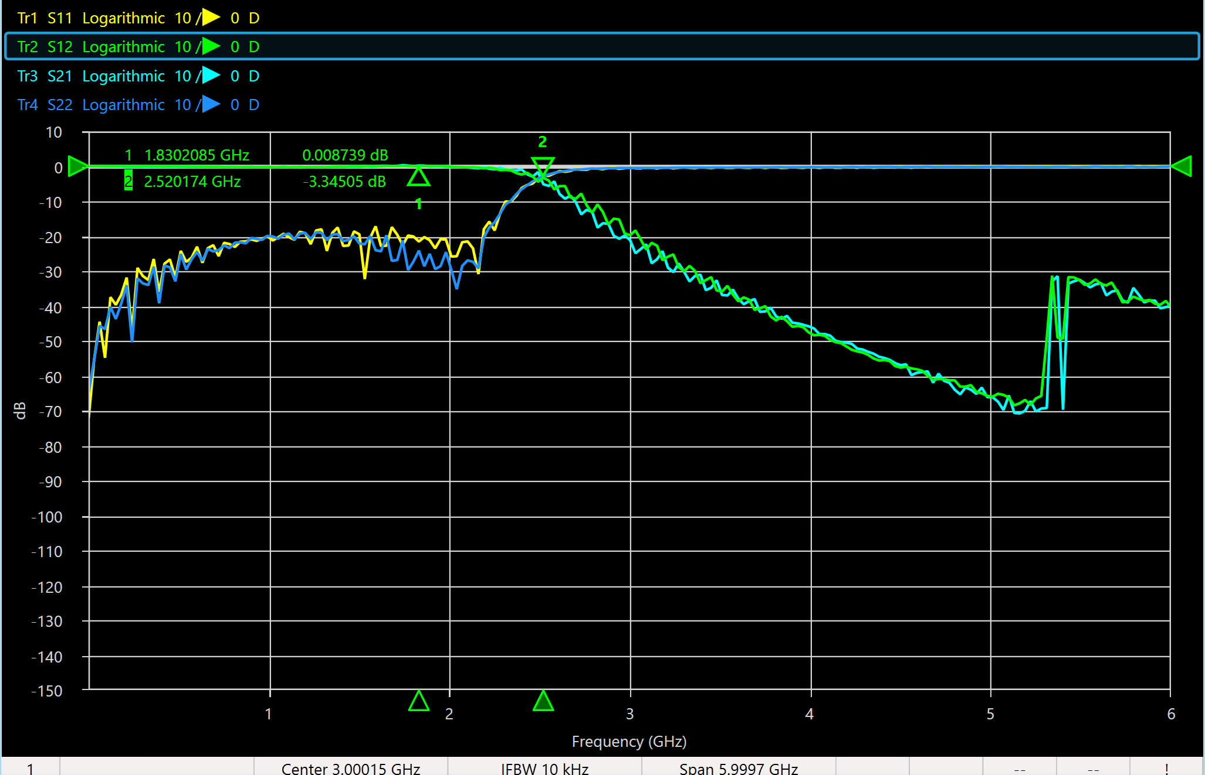

Insertion Loss = S21/S12 = -0.064 + 0.600 = 0.536 dB

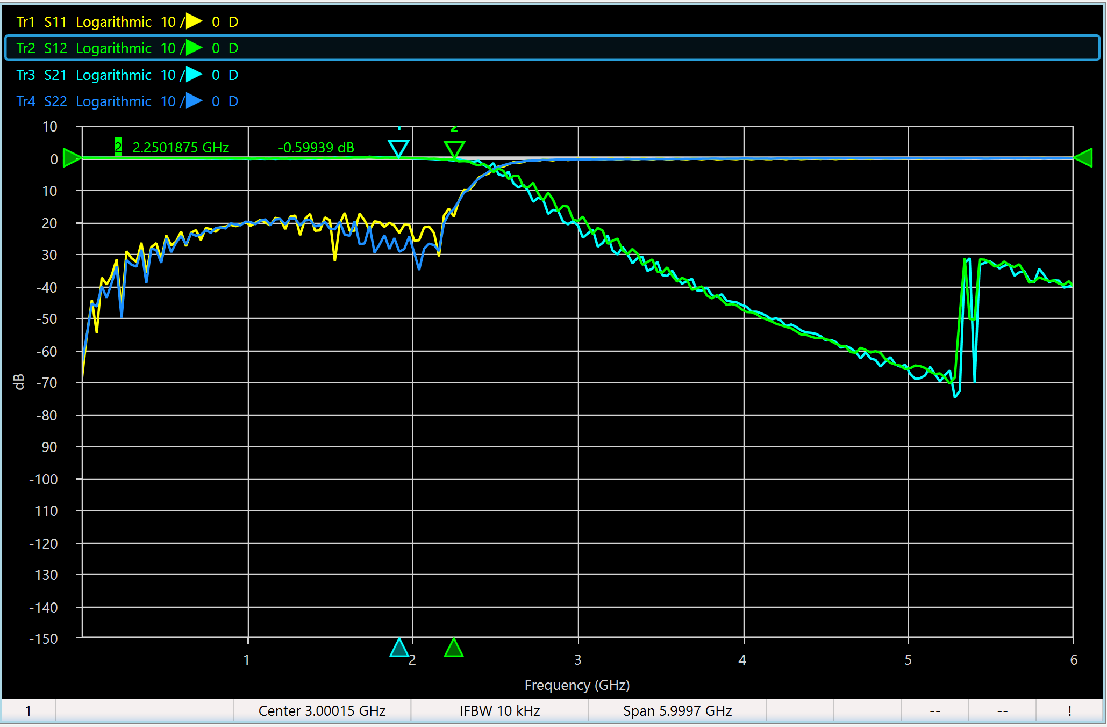

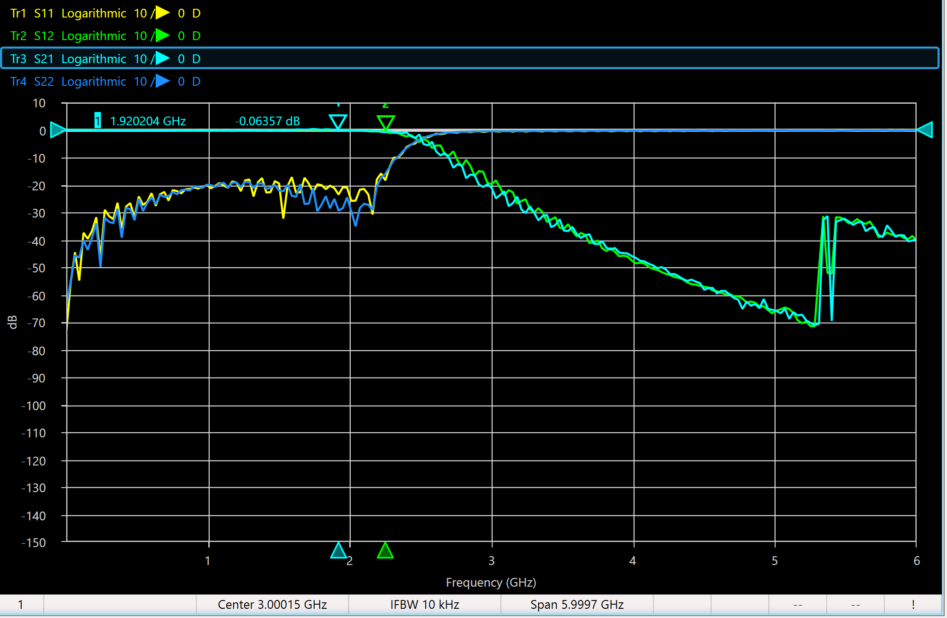

Return Loss = S22/S11 = -0.58 + 0.64 = 0.06 dB

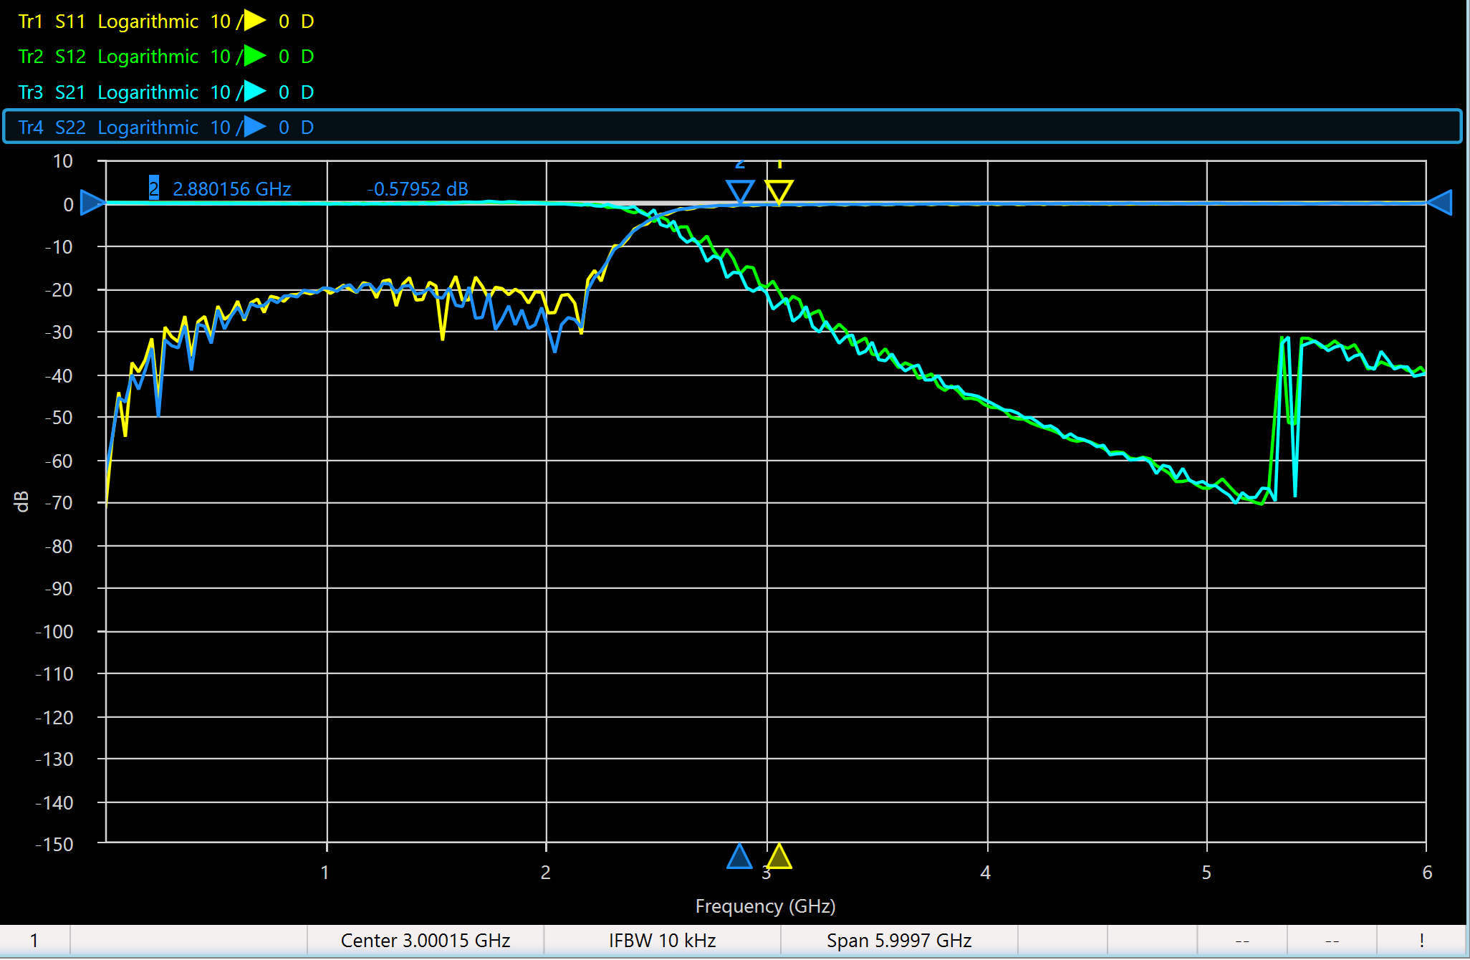

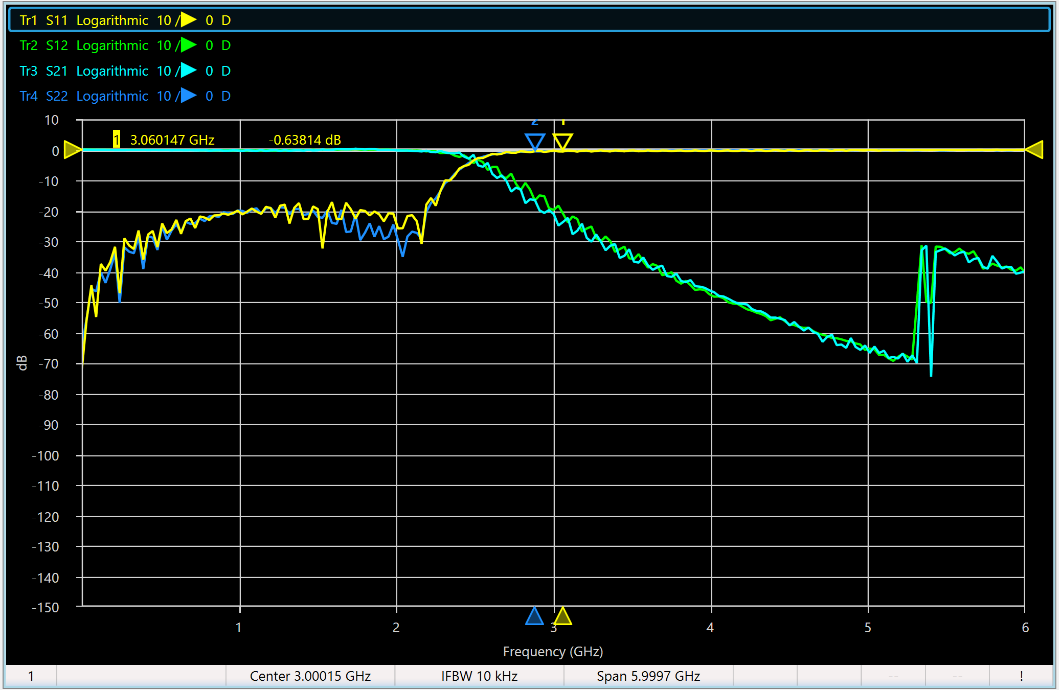

With frequency Response, which is very similar to S12:

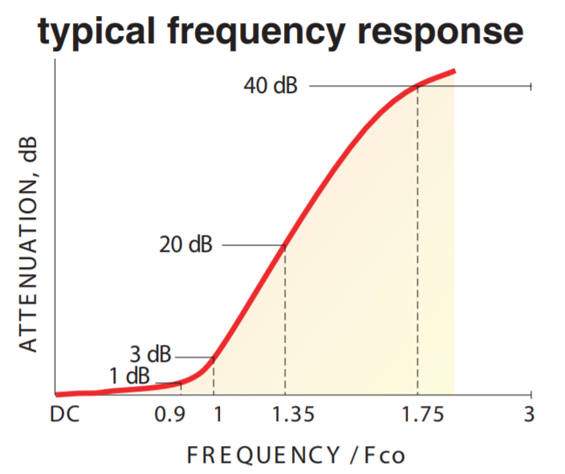

# Part 4: Analyses

1. **Compare your measurement results with the specifications provided in the datasheets.**

The specifications and measurements are similar each other. The bandwidth, return loss and insertion loss, from plots above have at most a 7% error. This is a given, since the equipment was physically measured in the lab.

1. **Which of the devices measured are lossless and which are reciprocal?**

Reciprocal: SLP-2400+, because S11 = S22, S12 = S21, VBFZ-2130+, for the same reason mentioned.

SLP-2400+ has a very low return loss. VBFZ-2130+ has a very low insertion loss. Even the VNA setup used in the first and second part is lossless.